Data Structure and Algorithm

Laboratory Activity No. 10

Intro to Graphs

|  |  |
| --- | --- |
| *Submitted by:* | *Instructor:* |
| Polestico,Paul Justine D. | Engr. Maria Rizette H. Sayo |

October, 11, 2025

# Objectives

Introduction

A graph is a visual representation of a collection of things where some object pairs are linked together. Vertices are the points used to depict the interconnected items, while edges are the connections between them. In this course, we go into great detail on the many words and functions related to graphs.

An undirected graph, or simply a graph, is a set of points with lines connecting some of the points. The points are called nodes or vertices, and the lines are called edges.

A graph can be easily presented using the python dictionary data types. We represent the vertices as the keys of the dictionary and the connection between the vertices also called edges as the values in the dictionary.

Figure 1. Sample graph with vertices and edges

This laboratory activity aims to implement the principles and techniques in:

* To introduce the Non-linear data structure – Graphs
* To discuss the importance of Graphs in programming

# Methods

* 1. Discuss the following terms related to graphs:
     1. Undirected graph
     2. Directed graph
     3. Nodes
     4. Vertex
     5. Degree
     6. Indegree
     7. Outdegree
     8. Path
     9. Cycle
     10. Simple Cycle

# Results

1.***Undirected Graph***

It refers to a type of graph where the edges have no specific direction assigned to them.

Unlike a Directed Graph, There is no **parent** or **child** vertex as there is no direction to the edges.

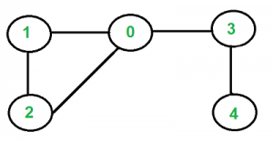

Figure 1 GeeksforGeeks,Example of undirected graph

2. ***Directed Graph***

It refers to a type of graph where unlike the Undirected Graph, the edges have a specific

direction assigned to them and there is a **parent** or **children** vertex as there is direction to

the edges.

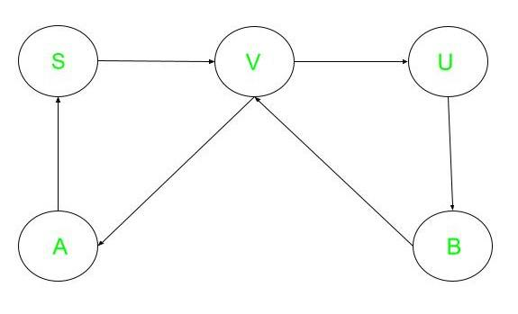

Figure 2 GeeksforGeeks,Example of a directed graph

3. ***Nodes***

A fundamental unit of a graph repsenting an **entity** in a graph.

Figure 3 GeeksforGeeks,Example of a Node

4. ***Vertex***

Another term for Node representing an **object** in a graph.

5. ***Degree***

The number of edges **incident** to that vertex. In other words, How many edges are connected to the parent node,similar to a family tree.

6. ***Indegree***

Refers to the number of edges coming from the last node to the parent node (**incoming edges**).

7. ***Outdegree***

Refers to the number of edges coming from the parent node to the last node. (**outgoing edges**).

8. ***Path***

A **sequence of vertices** adjacent to each other connected by an edge.

9. ***Cycle***  
A path that **starts and ends** at the same vertex, with no other vertices repeated.

10. ***Simple Cycle***  
A cycle that **cannot be broken down** into two or more smaller cycles. In other words, it is a closed path where no vertices (except the starting and ending vertex) are repeated.

Conclusion  
The previously mentioned terms are essential for better understanding graphs, especially in the context of programming and computer science. Mastering these concepts helps in solving problems related to networks, data structures, and algorithms. With a solid grasp of these fundamentals, you’ll be better equipped to analyze relationships, optimize processes, and implement efficient solutions in real-world applications.

**References**

[1] Co Arthur O.. “University of Caloocan City Computer Engineering Department Honor Code,” UCC-CpE Departmental Policies, 2020.

[2] GeeksforGeeks. (2025, July 23). *Graph terminology in data structure*. GeeksforGeeks. <https://www.geeksforgeeks.org/dsa/graph-terminology-in-data-structure/>

[3] GeeksforGeeks. (2025b, July 23). *What is Undirected Graph? | Undirected Graph meaning*. GeeksforGeeks. <https://www.geeksforgeeks.org/dsa/what-is-unidrected-graph-undirected-graph-meaning/>

[4] GeeksforGeeks. (2025a, July 15). *Find any simple cycle in an undirected unweighted Graph*. GeeksforGeeks. <https://www.geeksforgeeks.org/dsa/find-any-simple-cycle-in-an-undirected-unweighted-graph/>

[5] GeeksforGeeks. (2025c, July 23). *What is the difference between an undirected and a directed Graph?* GeeksforGeeks. <https://www.geeksforgeeks.org/dsa/what-is-the-difference-between-an-undirected-and-a-directed-graph/>